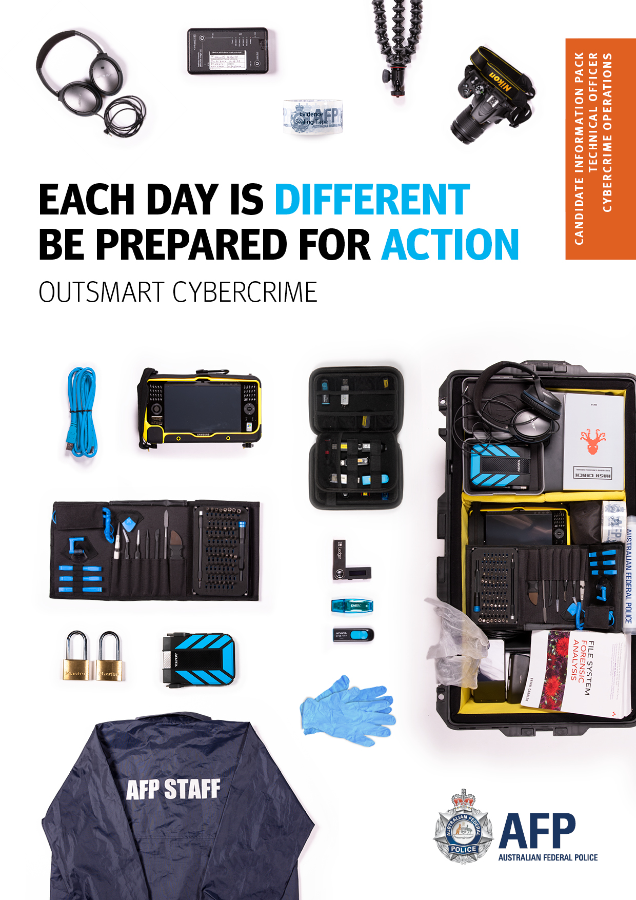

TECHNICAL OFFICER – BAND 4
The Australian Federal Police (AFP) has established itself as a key player in the Australian security landscape, rising to complex challenges and staying a step ahead of new and emerging threats. We are looking for the brightest minds to play a critical role in protecting Australians by outsmarting serious, complex, international and organised crime.
Crime is smart, so we need to be smarter. To be one of the most adaptive, effective and advanced police forces in the world, the AFP is seeking qualified candidates for Technical Officer, Cybercrime Operations roles across the organisation.
Our ideal candidates are driven by an intelligent, problem-solving approach to tackling serious crime. We are looking for qualified and experienced candidates who are willing to constantly adapt and learn to overcome problems put in their way.
AFP Cybercrime Operations' primary responsibility is to prevent, mitigate, investigate and prosecute computer related crimes under the Commonwealth Criminal Code Act 1995. In order to fulfill this responsibility, the AFP employs technical specialists capable of providing highly technical and sound advice in relation to computer exploitation events, overt and covert intelligence collections and lead development of new collection and analysis techniques to meet the demands of this fast paced and highly specialised crime type. The teams operate in a cooperative arrangement with Australian and international law enforcement agencies, the financial sector, key private sector and government organisations.
THE ROLE
The role sits under the Cybercrime Operations branch of the AFP, and will work alongside Senior Technical Specialists and Federal Investigators to assist with a variety of operational and support functions to Cybercrime Operations Teams. The primary purpose of the role is to enhance the technical capabilities of these teams and provide technical solutions to challenges encountered during the investigative process.

Essential Requirements
- negative Vetting 2 (Top Secret) security clearance or the ability to obtain one
- contemporary knowledge and experience relevant to the role
- minimum of 3 years’ experience in a directly relevant field (this may include skills and experience developed through tertiary studies, work experience or otherwise, and the ability to effectively demonstrate those skills
- demonstrated ability and willingness to learn new skills.

Desirable
- ability to obtain and maintain Top Secret Positive Vetting

The Application Process
The following steps must be completed prior to submitting your application online through MyCareer.
Applicants will be required to successfully complete the below selection gateways before selection:
- Pre-screening questions
- Assessment of application against requirements including review of application (pitch) and CV
- Interview
- Reference checks.

This recruitment process is being used to fill current Technical Officer vacancies and to create a pool for future vacancies.

Curriculum Vitae (CV)
Your application and CV (including work history, responsibilities and achievements) will form the basis for determining your suitability against the selection criteria and position requirements.

Two page pitch
The two page pitch will assess you against the role scope and selection criteria.

Ensure your pitch is written with examples of ability to demonstrate capability at the Band 4 work level standards.
The panel is only able to consider the evidence they receive from candidates, therefore ensure your pitch clearly demonstrates your ability to address the selection criteria.

Formal Interview
Applicants who have demonstrated their suitability for the position through their resume and pitch, may be invited to a formal interview.

Using the selection criteria as a guide, you may be asked a range of questions to demonstrate your skills and abilities - including communication, technical skills and knowledge.

You can prepare for the interview by:

- reviewing your responses to the selection criteria, picking a few additional examples to use in the interview; and
- participating in a mock interview with a friend using the selection criteria to think of possible questions.

Feedback

Feedback for this process will be provided to applicants as follows:

Application – due to expected large volume of applications, unsuccessful applicants will not receive summarised feedback regarding their two page pitch. Successful applicants who progress to interview will not receive feedback on their pitch.
Formal Interview – successful and unsuccessful applicants will receive their individual assessment and also verbal and/or written feedback at the end of the recruitment process if requested.
Note: end of the recruitment process is when the delegate has approved the SAC report.

How to Apply
Applications for this position must be submitted through the AFP recruitment system MyCareer.
Please ensure that you upload all required documents to your application.
Applications open on 26 November 2020.
Helpful information
Work level standards

Further Enquiries
After reading the selection documentation, if you require further information please contact:

Contact Officer: David Lord
Phone: (02) 5126 4765
Email: David.Lord@afp.gov.au

Role Scope - Technical Officer
Cybercrime Operations (Band 4)

Role Summary

Applications are sought from suitably qualified applicants wishing to be considered for the role of Technical Officer.
The Technical Officer position does not require the use of police powers. Members engaged in this role will form part of the professional stream.
AFP Cybercrime Operations' primary responsibility is to prevent, mitigate, investigate and prosecute computer related crimes under the Commonwealth Criminal Code Act 1995. In order to fulfill this responsibility, the AFP employs technical specialists capable of providing highly technical and sound advice in relation to computer exploitation events, overt and covert intelligence collections and lead development of new collection and analysis techniques to meet the demands of this fast paced and highly specialised crime type. The teams operate in a cooperative arrangement with Australian and international law enforcement agencies, the financial sector, key private sector and government organisations.

The role sits under the Cybercrime Operations branch of the AFP, and will work alongside Senior Technical Specialists and Federal Investigators to assist with a variety of operational and support functions to Cybercrime Operations Teams. The primary purpose of the role is to enhance the technical capabilities of these teams and provide technical solutions to challenges encountered during the investigative process.

The following positions will be available and offered:

- Canberra - Permanent Full time position
- Sydney - Permanent Full time position
- Melbourne - Permanent Full time position
As a Team Member in the AFP you will be required to contribute to the achievement of outcomes in accordance with the regulatory framework, the AFP Code of Conduct and the AFP Governance Instruments. It is expected that the successful applicant will deliver on the core responsibilities and meet any requirements of the position as outlined below.
Role Description & Responsibilities

The role will include a variety of technical tasks, such as:
- Providing technical assistance to investigations.
- Testing and maintaining hardware and software platforms.
- Procuring and standardising investigations datasets for analysis.
- Programmatically collating disparate data sources from large data sets.
- Assisting with technical review and analysis of digital evidence.
- Developing new and innovative investigative capabilities through software development using coding languages such as Python, Java and C
- Producing business documentation for new capabilities and processes.
Essential Requirements

- A Negative Vetting 2 (Top Secret) security clearance or the ability to obtain one.
- Has contemporary knowledge and experience relevant to the role.
- Minimum of 3 years’ experience in a directly relevant field (this may include skills and experience developed through tertiary studies, work experience or otherwise, and the ability to effectively demonstrate those skills.
- Demonstrated ability and willingness to learn new skills.
Selection Criteria

- Organising your work, making sound decisions and achieving outcomes
- Communicating and working effectively with other people
- Applying technical knowledge, expertise and skills

Required Application Documents

As part of your application you will be required to submit the following documents:

- Applicant response (pitch-maximum two pages)
- Resume/CV

Advice for Internal Applicants

All requested documents must be uploaded to the application form and submitted before the closing date and time. Any documents not supplied may result in your application being withdrawn from the recruitment process.
The applicant response (pitch) should address the selection criteria and work level standards relevant to the role and provide evidence as to why you are the best fit for the position.
The work level standards are specific to the band level of the role you are applying for and can assist in guiding you to address the selection criteria to the level required of the role.

Applicant Guide
Developing a two page pitch – Band 4 Technical Officer
November 2020

Applicant Guide – How to develop a two page pitch when applying for positions
Why move to a two page pitch?
The AFP have implemented a two page (maximum) pitch process to make it easier for you to apply for positions and best showcase why your experience and personal attributes make you suitable for the vacancy.

How can you develop your pitch?
Before you begin to plan and develop your response, you need to ensure that you review the position requirements and responsibilities, selection criteria and other relevant information such as team overview and key working relationships in the job advertisement or candidate information package. The Work Level Standard for the position can provide further information about role expectations. Also make contact with the contact person for the position if you require more specific details.

What to include in your pitch?
The CV provides us with your career history and evidence of technical expertise. With the Pitch you need to demonstrate your technical attributes against the work level standards, and demonstrate your potential to perform at the Band 4. It is also important to focus on not only telling what you have done but also provide insight into how you did what you did and why you did it that way.
In demonstrating your technical attributes against the work level standards, utilise key examples to convey:
• What challenge were you facing;
• What skills you demonstrated to address this challenge; and
• What was the outcome for the AFP.

Close with a strong statement about why you should be chosen to undertake this role.

Some do’s and don’ts when developing your pitch

DO’s
- Know the two to three messages that you want to share to ensure that you stay on message and highlight your technical claims against the selection criteria;
- You might prefer to use one or two work examples that showcase all criteria rather than a separate example for each criteria. Just remember all examples must be relevant and easy for the reader to link back to your CV;
- Remember document design principles such as a readable font size and use of white space. Use real examples – don’t only ‘tell’ of your skills and experience through general statements;
- CHECK your response for relevance, typos and flow before submitting.

DON’T:
- Don’t use dot points
- Don’t use examples that are demonstrating technical skills
- Don’t use PDA comments
- Don’t be tempted to use small font or narrow margins to maximise word usage in your response. This will make it very difficult for the selection panel to read. The skill in developing a pitch is to develop a short but relevant document. This requires practice.
- Don’t replicate your CV and reference to technical expertise in the Pitch, the Pitch is about ‘demonstrating your technical attributes against the work level standards’
- Don’t submit a pitch longer than two pages. This may make your application ‘stand out’ in a non-favourable way as you have not attempted to craft a succinct but highly relevant response.

Practice
Remember to consider feedback from previous recruitment processes in developing and refining your future pitches. Strive to always improve, better highlight and present your claims in a logical order that relates to the position vacancy.

Further resources: How to write and talk to Selection Criteria: Dr Ann Villiers

