AFP NPC FORM-8022
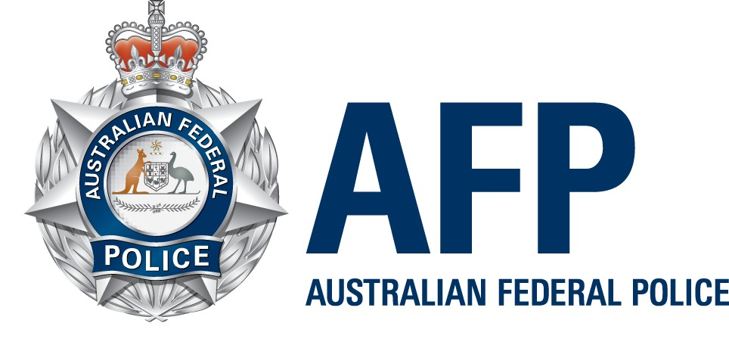

NATIONAL POLICE CHECK (NPC) 100 POINT CHECKLIST FOR IDENTIFICATION DOCUMENTS

A minimum of 100 points of identification has to be provided with an application. Use this as a checklist when preparing your identification documents.

Identification Documents - 100 Point Checklist

Tick if included
You must supply at least ONE Primary document  Foreign documents must be accompanied by an official translation | Required on document  N = Name, P = photo  A = Address, S = Signature | Points Worth | Points gained

Primary Documents
Foreign Passport (current)
Australian Passport (current or expired within last 2 years but not cancelled)
Australian Citizenship Certificate
Full Birth certificate (not birth certificate extract)
Certificate of Identity issued by the Australian Government to refugees and non Australian citizens for entry to Australia
Australian Driver Licence/Learner’s Permit
Current (Australian) Tertiary Student Identification Card
Photo identification card issued for Australian regulatory purposes (e.g. Aviation/Maritime Security identification, security industry etc.)
Government employee ID (Australian Federal/State/Territory)
Defence Force Identity Card (with photo or signature)

Secondary Documents
Department of Veterans Affairs (DVA) card
Centrelink card (with reference number)
Birth Certificate Extract
Birth card (NSW Births, Deaths, Marriages issue only)
Medicare card
Credit card or account card
Australian Marriage certificate (Australian Registry issue only)
Decree Nisi / Decree Absolute (Australian Registry issue only)
Change of name certificate (Australian Registry issue only)
Bank statement (showing transactions)
Property lease agreement - current address
Taxation assessment notice
Australian Mortgage Documents - Current address
Rating Authority - Current address eg Land Rates
Utility Bill - electricity, gas, telephone - Current address (less than 12 months old)
Reference from Indigenous Organisation
Documents issued outside Australia (equivalent to Australian documents). Must have official translation attached
Total points provided (minimum 100):

